AUTOMOBILE ACCIDENT QUESTIONNAIRE
Dear Patient: We need this information because we care enough to want to know, and your answers will help us determine if chiropractic care can help you. If we do not sincerely believe your condition will respond satisfactorily, we will not accept your case. In order for us to understand your condition properly, please be as neat and accurate as possible. Thank You

Name_______________________________ Today’s Date___________ Sex: M or F Marital Status: S M D W
Address____________________________________ City________________ State________ Zip____________
Home Phone #_____________________ Cell #_______________________ Work #______________________
Date of Birth___________ SS #_______________ Occupation_________________ Employer______________
Email_________________________ How did you hear about us?_____________________________________
ACCIDENT INFORMATION
Driver of Vehicle in which you were injured______________________________ Relationship______________
The Date of Accident____________________________________ Time of Accident_______________________
You were heading ( ) North ( ) South ( ) East ( ) West on ___________________________(street or highway)
Other vehicle was heading ( ) North ( ) South ( ) East ( ) West on ____________________________________
You were struck from ( ) Behind ( ) Front ( ) Left side ( ) Right Side
You were ( ) Driver ( ) Front Passenger ( ) Rear Passenger Seat Belts Used? ( ) Yes ( ) No
Where did you feel pain immediately after the accident? ___________________________________________
Where were you taken after the accident? _______________________________________________________
Was any Doctor consulted after the accident? ( ) Yes ( ) No Doctor’s Name ___________________________
What treatment was given? ___________________________________________________________________
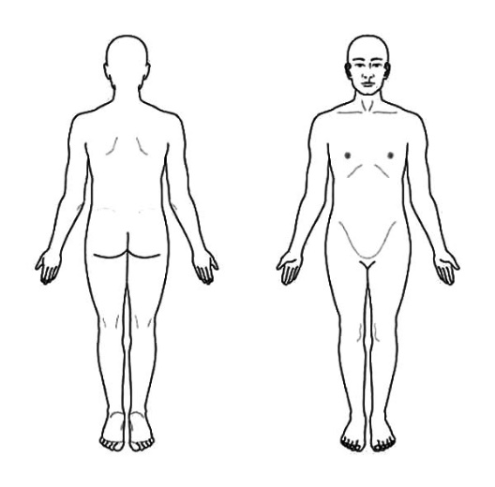
What was the diagnosis? _____________________________________
Have you had any complaints in the involved area before? ( ) Yes ( ) No
If so, what were the complaints? _______________________________
Are your work activities restricted as a result of this accident? ( ) Yes ( ) No
Since the injury, are symptoms ( ) Improving ( ) Getting Worse ( ) Same
PLEASE MARK YOUR AREAS OF PAIN ON THE FIGURES AT RIGHT > left right left
Name of Your Auto Insurance __________________ Policy #___________
Do you have Med Pay? ( ) Yes ( ) No If yes claim #____________________
Name of Your Insurance Adjustor__________________ Phone #_________
Name of Your Health Insurance ____________________________________

Name of Other Driver’s Auto Insurance______________________ Policy #_______________
Claim #______________________ Name of Insurance Adjustor___________________ Phone #____________
Have you retained an Attorney? ( ) Yes ( ) No Name and address_____________________________________
Please explain how your accident happened ______________________________________________________
__________________________________________________________________________________________
__________________________________________________________________________________________
__________________________________________________________________________________________

HEALTH QUESTIONNAIRE:
Please indicate for each of the questions below your experience by use of the following codes:
1 – Never: 2 – Previously had: 3 – Presently have

Musculo-Skeletal System

( ) Low back problems
( ) Pain between shoulders
( ) Neck problems
( ) Leg problems
( ) Swollen joints
( ) Stiff joints
( ) Sore muscles
( ) Weak Muscles
( ) Walking problems
( ) Ruptures
( ) Broken bones

Genito-Urinary System

( ) Bladder trouble
( ) Excessive urination
( ) Scanty urination
( ) Painful urination
( ) Discolored urine

Female

( ) Abnormal vaginal discharge
( ) Abnormal vaginal bleeding
( ) Abnormal vaginal pain
( ) Breast pain
( ) Lumps on breasts
Are you pregnant?
( ) Yes ( ) No

Gastro-Intestinal

( ) Poor appetite
( ) Excessive hunger
( ) Difficulty swallowing
( ) Difficulty chewing
( ) Excessive thirst
( ) Nausea
( ) Vomiting blood
( ) Abdominal pain
( ) Diarrhea
( ) Constipation
( ) Black stool
( ) Bloody stool
( ) Hemorrhoids
( ) Liver trouble
( ) Gall bladder problems
( ) Weight trouble

Nervous System

( ) Numbness
( ) Loss of feeling
( ) Paralysis
( ) Dizziness
( ) Fainting
( ) Headaches
( ) Muscle jerking
( ) Convulsions
( ) Confusion
( ) Depression

Eye, Ear, Nose & Throat

( ) Eye strain
( ) Eye inflammation
( ) Vision problems
( ) Ear pain
( ) Ear noises
( ) Ear discharge
( ) Hearing loss
( ) Nose pain
( ) Nose bleeding
( ) Sore gums
( ) Dental Problems
( ) Sore mouth
( ) Sore throat
( ) Hoarseness
( ) Difficult speech
( ) Hard to breathe/nose

Cardio-Vascular/Respiratory

( ) Chest pain
( ) Pain over heart
( ) Difficulty breathing
( ) Persistent cough
( ) Coughing phlegm
( ) Coughing blood
( ) Rapid heartbeat
( ) Heart problems
( ) Lung problems
( ) Varicose veins
( ) High blood pressure

I understand and agree that health and accident insurance policies are an arrangement between an insurance carrier and myself. Furthermore, I understand that the Doctor’s office will prepare any necessary reports and forms to assist me in making collection from the insurance company and that any amount authorized to be paid directly to the Doctor’s office will be credited to my account upon receipt. However, I clearly understand and agree that I am personally responsible for payment. I also understand that if I suspend or terminate my care and treatment, any fees for professional services rendered me will be immediately due and payable.
I hereby authorize the Doctor to examine me and treat my condition as he/she deems appropriate through the use of Chiropractic Health Care and I give authorization for these procedures to be performed. I also agree that I am responsible for all bills incurred in this office including any balance not paid by Health Insurance for the treatment of the auto accident related injuries. The Doctor will not be held responsible for any pre-existing, medically diagnosed conditions nor for any medical diagnosis.

Patient’s/Guardian’s Signature_____________________________________________ Date________________________________

